|  |  |
| --- | --- |
| Semester | T.E. Semester V – Computer Engineering |
| Subject | Software Engineering |
| Subject Professor In-charge | Prof. Sneha Annappanavar |
| Assisting Teachers | Prof. Sneha Annappanavar |
| Laboratory | M313B |

|  |  |
| --- | --- |
| Student Name | Deep Salunkhe |
| Roll Number | 21102A0014 |
| TE Division | A |

**Title: Display Graphical Primitives**



**Implementation:**

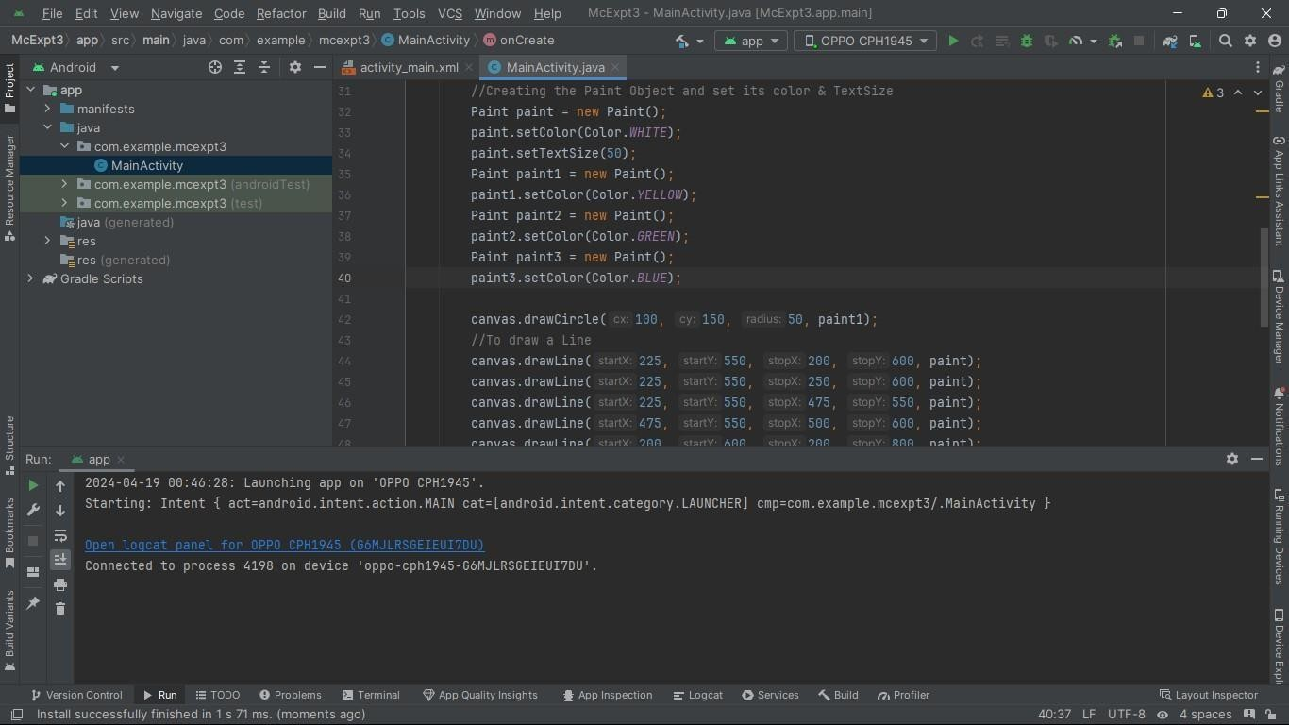

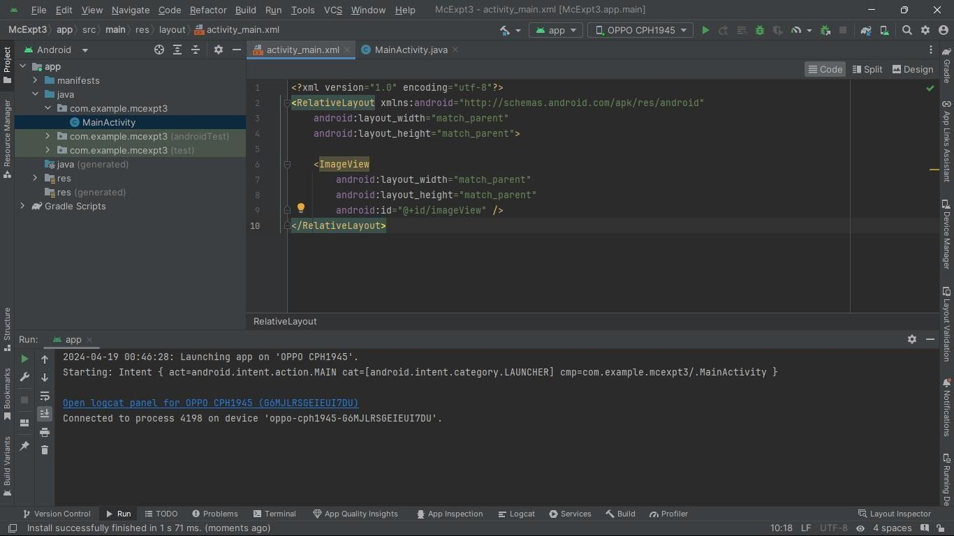



**Output:**

